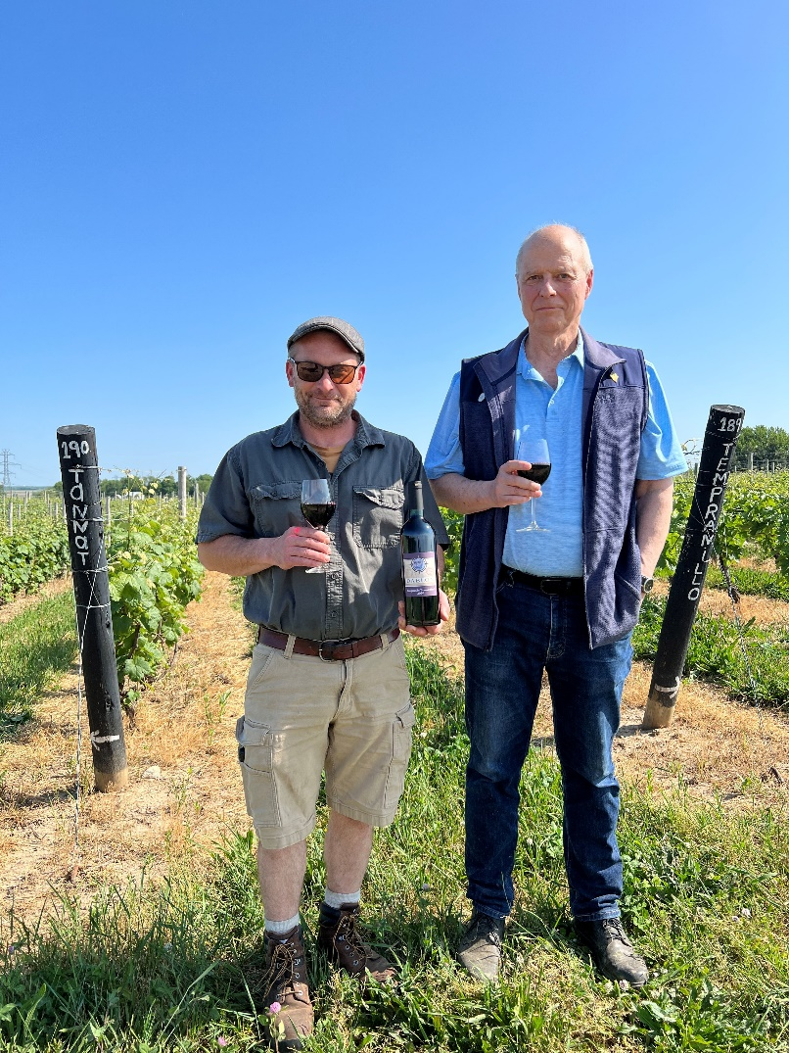

**FOR IMMEDIATE RELEASE  
JUNE 1, 2023  
PRESS RELEASE: Dablon Vineyards Releases  
2020 Estate Tempranillo Tannat Blend**

Baroda, Michigan   
Winery: Dablon Vineyards & Winery  
Dablon Vineyards is releasing this month its 2020 Estate Tempranillo Tannat Blend. Since we began growing Tannat grapes 12 years ago and Tempranillo grapes 6 years ago we have been looking for the best Tempranillo estate blend that both respects Spain’s Rioja tradition but also uses a blending grape to produce a blend unique in our region and rare in the world. Our 90% Tempranillo, 10% Tannat blend had the varietals aging separately in French oak for over one year, was blended and bottled in April 2022 and has been bottle aging since.

At bottling the wine had:  
Alcohol: 13.5%  
PH: 3.49  
TA: .94  
Residual Sugar: 0%

Current Tasting Room Bottle: $38

*Photo (Left-Right): Rudy Shafer (Wine Maker) and William Schopf (Owner) on the Dablon Vineyards Estate with a bottle of the 2020 Estate Tempranillo Tannat Blend.*

This wine is ready to drink now and suitable as well for considerable aging. With both varietals having strong tannins and acids, the blend has benefited from the barrel and bottle time. Please allow the wine to breathe 30 minutes or more after opening. Head winemaker, Rudy Shafer, elaborates, "The 2020 Tempranillo Tannat blend opens up with mild oak, earthy leather notes and red-fruit based aromas. On the palate it displays a medium body, plush tannins, crisp acidity and leads to flavors of tart cherries, crisp apples and raspberry."

*ABOUT DABLON VINEYARDS LLC: Dablon is an estate winery located on the glacier created hills in SW Michigan about five miles from Lake Michigan. Dablon grows 17 different varietals on its estate from which it makes and releases over 30 different vintages of estate wines annually. In March of this year Midwest Living Magazine awarded Dablon the title of Best Winery in the 12 state Midwest region.*

[*https://www.winebusiness.com/news/article/268090*](https://www.winebusiness.com/news/article/268090)[*www.dablon.com*](http://www.dablon.com)

For information contact:  
April Bredy  
Business & Marketing Manager  
[business-marketing@dablon.com](mailto:business-marketing@dablon.com)  
(708) 404-4900